Analysis of Competitive Advantage in

Real Companies



NAME: GLORIA SAGAR

DR LANKAPALLI BULLAYYA COLLEGE

BBA FINAL YEAR

DATE : 18/03/2024

TABLE OF CONTENTS

# Introduction.

# a.Aim of the analysis

# b. Company overview.

# 2.Competitive Advantage.

# i. Analysis of the company.

# 3.Analysis of financial performance.

# 4.Comparison of Company’s position in industry.

# 5.Future Scope of strategies and opportunities.

# 6.Conclusion & bibliography.

# 

# 

# 

INTRODUCTION

**AIM OF THE ANALYSIS:**

1.To analyse the competitive advantages of two real companies operating in different industries.

a.technology sector

b. Consumer goods sector

2. Identify, evaluate the competitive strengths that contribute to each company’s success.

3. To evaluate the financial performance of both companies.

4. To ascertain the long term viability of the company’s competitive advantage.

## **COMPANY OVERVIEW:**

* This section will provide a summary about both the companies and key insights



**Amazon,inc:** Amazon is an American multinational technology company, engaged in e-commerce, cloud computing, online advertising, digital streaming, and artificial intelligence. It is considered one of the Big Five American technology companies; the other four are Alphabet (parent company of Google), Apple, Meta (parent company of Facebook), and Microsoft.

Amazon was founded on July 5, 1994, by Jeff Bezos in Bellevue, Washington.The company originally started as an online marketplace for books but gradually expanded its offerings to include a wide range of product categories. This diversification led to it being referred to as "The Everything Store"Amazon was founded on July 5, 1994, by Jeff Bezos in Bellevue, Washington.The company originally started as an online marketplace for books but gradually expanded its offerings to include a wide range of product categories. This diversification led to it being referred to as "The Everything Store"

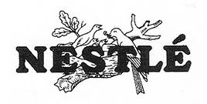

## **NESTLE :**

**Nestlé**  is a Swiss multinational food and drink processing conglomerate corporation headquartered in Vevey, Switzerland. It has been the largest publicly held food company in the world, measured by revenue and other metrics, since 2014. It ranked No. 64 on the *Fortune* Global 500 in 2017 In 2023, the company was ranked 50th in the Forbes Global 2000.

Nestlé's products include baby food (some including human milk oligosaccharides), medical food, bottled water, breakfast cereals, coffee and tea, confectionery, dairy products, ice cream, frozen food, pet foods, and snacks. Twenty-nine of Nestlé's brands have annual sales of over

1 billion CHF ] including Nespresso, Nescafé, Kit Kat, Smarties, Nesquik, Stouffer's, Vittel, and Maggi. Nestlé has 447 factories, operates in 189 countries, and employs around 339,000 people.] It is one of the main shareholders of L'Oreal, the world's largest cosmetics company.

Competitive Advantage

This section illustrates the competitive advantage .i.e the strengths of both companies amazone & nestle on the basis of brand image ,Product mix and leadership style.

# **AMAZON**

**1. Strong Brand Image**

As a global e-commerce giant, Amazon has a strong position and successful brand image in the market.

**2. Brand Valuation**

According to Interbrand’s Global Brand Ranking 2022, Amazon is ranked at #3 position (Apple at #1 and Microsoft at #2), with a brand value of $274 Billion.

**3. Customer Oriented**

Amazon caters to a large number of customers for everyday needs at inexpensive prices. This has made it a customer-oriented brand.

**4. Differentiation and Innovation**

Amazon frequently brings creative ideas and innovative additions to its product line and service offerings like ambitious drone delivery service and Withings Aura Smart Sleep System. This creates a differentiation from other companies.

**5. Cost Leadership**

Amazon doesn’t incur costs in maintaining physical retail stores by selling everything online. With economies of scale, Amazon efficiently controls its costs and lowers its inventory replenishment time. The company has formed numerous strategic alliances with many companies like Evi Technologies, Thalmic Labs, Shoefitr, The Orange Chef etc. It has a strong value chain system which also helps in maintaining a low-cost structure.

# **NESTLE**

**1. Largest Food Company**

With a market capitalization of $330+ Billion, Nestle has been one of the largest food companies in the world with the sales of its Hot Pockets, Stouffer’s, DiGiorno, and Nespresso etc.

**2. Reputed brand name**

Nestle is the most renowned brand in the world. It has developed a respected reputation in the food and beverages sector offering high-quality products for everyday use across the globe.

**3. Brand valuation**

Nestle is well positioned for growth. In 2021, Nestle ranked at #62nd position by Interbrand – with a brand value of $10.6 billion, moved up 1 place compared with 2020. Nestle is preceded by

1. #28 – Pepsi (Brand value: $19.4 billion)
2. #51 – Starbucks (Brand value: $13.0 billion)
3. #65 – Danoe (Brand value: $9.8 billion)
4. #72 – Kellogg’s (Brand value $8.6 billion)

**4. Highly diversified portfolio**

Nestle owns more than 2000 brands globally and renovated over 8000 products. It is one of the worlds’ biggest companies with the broadest and diverse product portfolio.

Nestle divides its products into 7 different categories:

* Powdered and Liquid Beverages—this is the largest segment of Nestle and represents about 28% of total revenue. This segment sells soluble coffee and other beverages such as tea and chocolate powder.
* Signature brands include Nescafe, Nespresso, Starbucks coffee (licence deal), Blue Bottle Coffee, Milo, and Nestea.

Analysis of Financial Performance

For FINANCIAL PERFORMANCE ANALYSIS & EVALUATION of both Amazon and Nestle the following parameters/ metrics have been used.

**AMAZON’S FINANCIAL ANALYSIS**

# 1.ANNUAL REVENUE GROWTH RATEAmazon's Annual Revenue

* The annual revenue of amazon for the year 2023 was $574,785 million, a growth of 11.83% from last year.
* The annual revenue of amazon for the year 2022 was $513,983 million, a growth of 9.4% from last year.
* The annual revenue of amazon for the year 2021 was $469,822 million, a growth of 21.7% from last year.

# 2.ANNUAL GROSS PROFIT

* Amazon‘s annual gross profit for 2023 was $270,046 million. The highest over the decade from 2013 to 2023.
* Amazon’s lowest annual gross profit was in 2009 starting at $5,531 million.

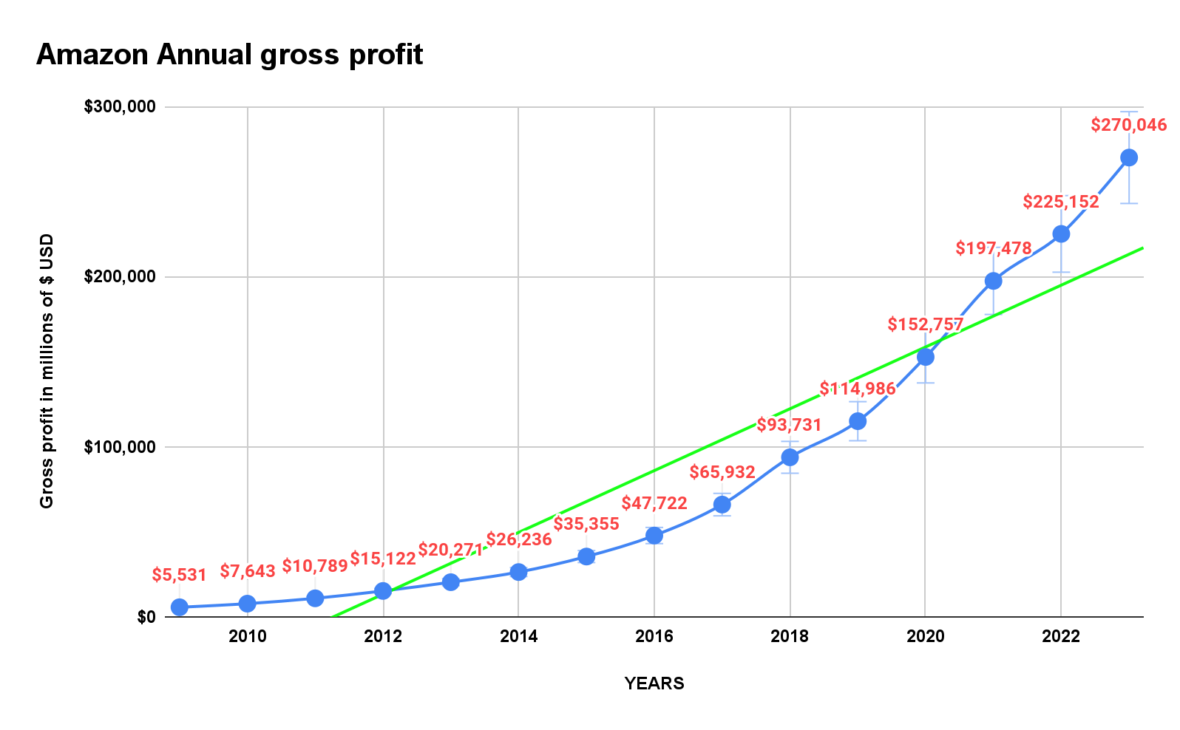

# 3.ANNUAL RETURN ON INVESTMENTAmazon Yearly Return On Investment

# 4.MARKET CAPITALISATION

**NESTLE S.A’s FINANCIAL ANALYSIS**

1.ANNUAL REVENUE GROWTH RATE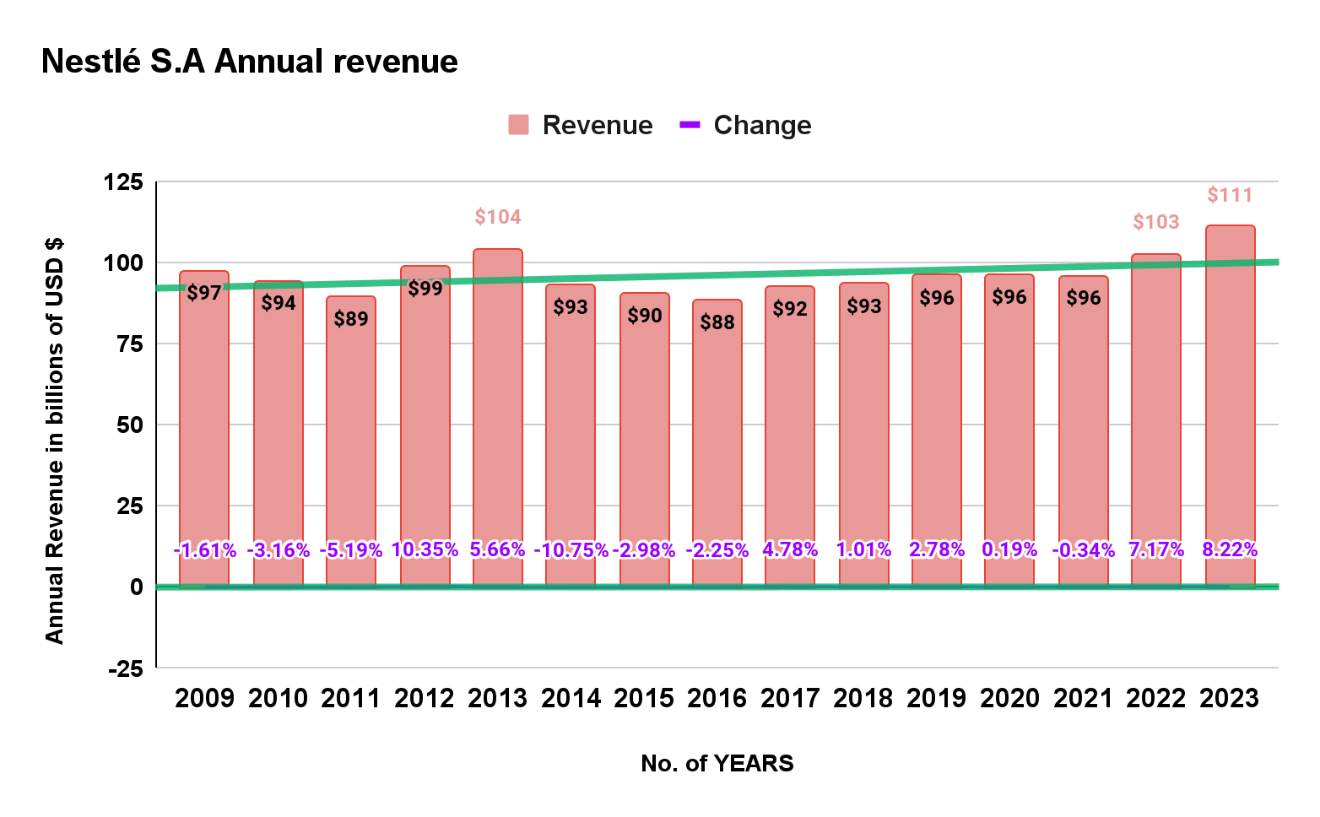

* The annual revenue of Nestle S.A for 2023 was $111 billion, a growth of 8.22% from last year.
* The annual revenue of Nestle S.A for 2022 was $103 billion, a growth of 7.17% from last year.
* The annual revenue of Nestle S.A for 2021 was $96 billion, a growth of 0.34% from last year.

2.ANNUAL OPERATING MARGIN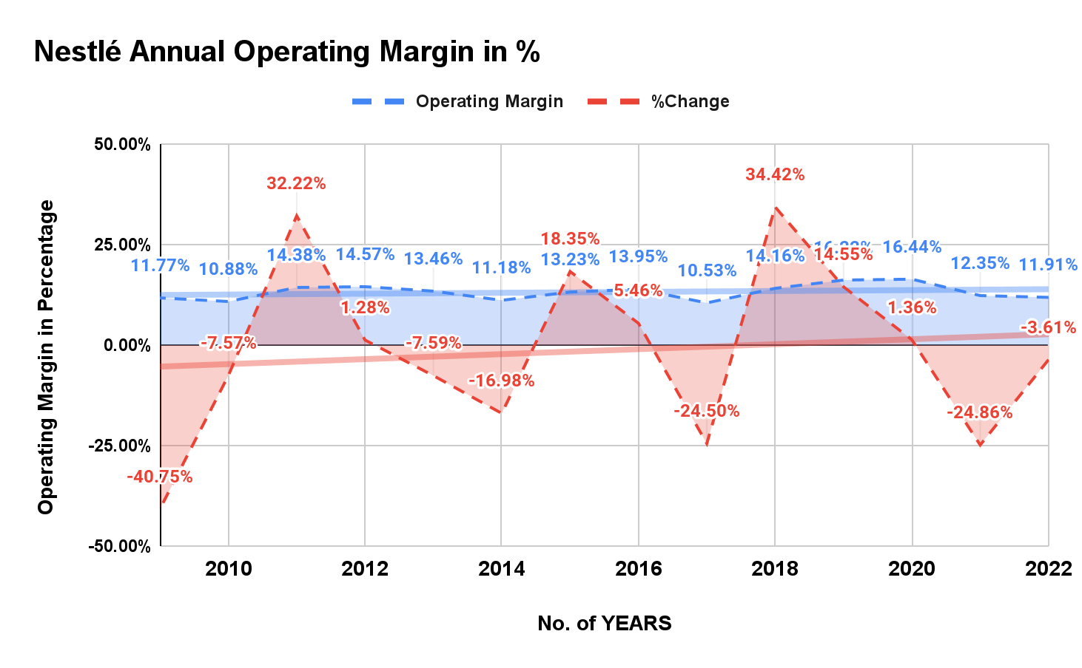

-

* The highest operating margin for Nestle was for the year 2020 at 16.44%, a positive change of 1.36 from 2019.
* The Operating margin for year 2022 of Nestle was 11.91%, a decline of -3.61 from 2021.

**3. MARKET CAPITALISATION**

MARKET CAPITALISATION is generally calculated on the number of shares that are outstanding for a company. The below chart shows the market cap **Nestle S.A** for years 2012 to 2024.

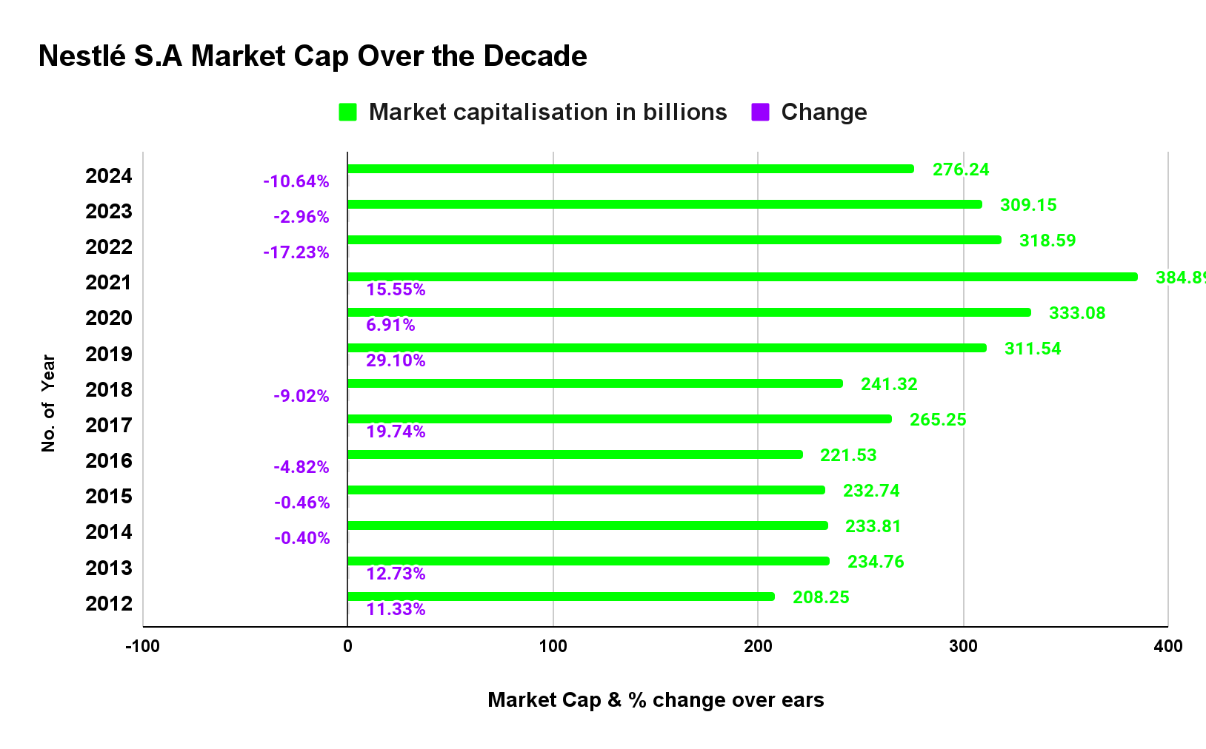

COMPARISON OF MARKET POSITION

# **#1 AMAZON.COM, INC:**MARKET SHARE OF THE BIG THREE E-COMMERCE GAINTS

# #2 **NESTLE S.A :**

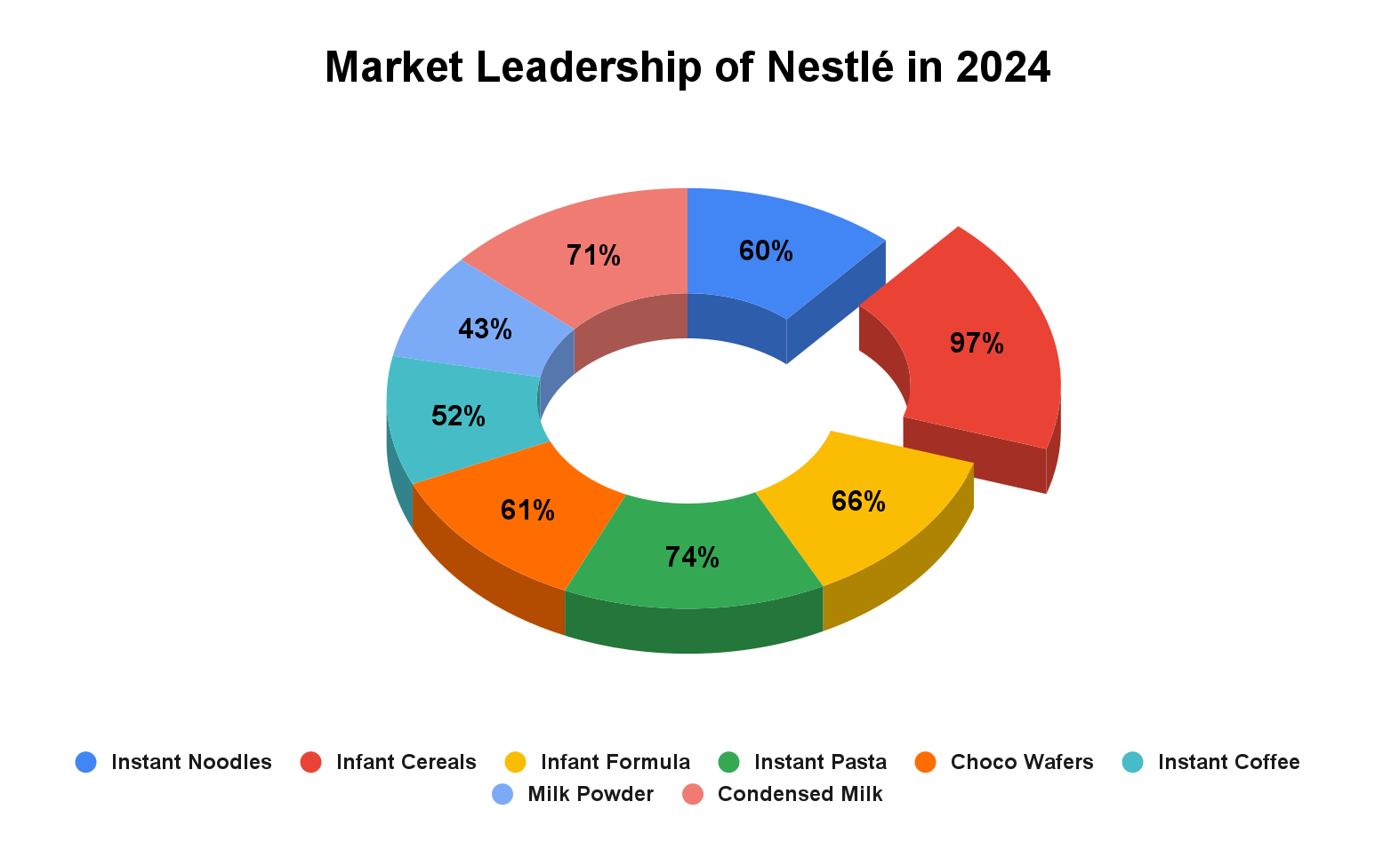

* Nestle is the market leader when it comes to various segments of CONSUMER GOODS INDUSTRY. From the above Pie chart it can be concluded that Nestle boasts the highest market in the following Product markets. I.e
  1. Instant noodles
  2. Infant cereals
  3. Infant formula
  4. Instant past
  5. Choco wafers
  6. Instant coffee
  7. Milk powder
  8. Condensed milk
* Therefore, Nestle S.A has been the no. in all this product market with majority of market share, customers and brand value in its possession.

FUTURE SCOPE OF STRATEGIES AND OPPORTUNITIES 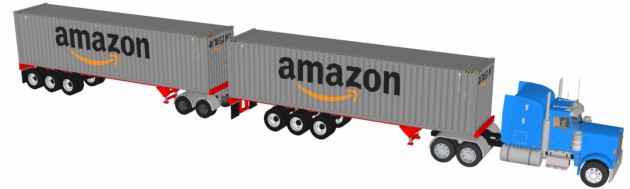

# **AMAZON.COM, INC**

## **INTRODUCTION:**

Since its humble beginnings in Jeff Bezos’ family garage in 1994, Amazon has grown to become a powerhouse in the e-commerce industry. Ranked 36th in Forbes’ Global Top 2000 list, the company reported an impressive US$33.4 billion in profit in 2022 and employs around 1.5 million people globally. Founder Jeff Bezos has become a household name, joining the ranks of the world’s richest individuals alongside visionaries like Elon Musk, Bill Gates, and Larry Ellison.

## **NET ZERO CARBON EMISSION GOALS:**

One of the most significant commitments made by Amazon is through “The Climate Pledge,” an initiative founded by the company and Global Optimism. The pledge aims to achieve net-zero carbon emissions by 2040, a full decade ahead of The Paris Agreement’s timeline. Amazon recognizes its responsibility as a global corporation to lead the charge in combating climate change, and the company is taking proactive steps to reduce its carbon footprint and transition to a low-carbon economy.

## **ELECTRIC VEHICLES DRIVING SUSTAINABILITY:**

###### Recognizing the significant impact of its delivery fleet on carbon emissions, Amazon has set forth a comprehensive plan to incorporate more electric vehicles (EVs) into its operations. The transportation sector is a major contributor to greenhouse gas emissions, and transitioning to electric vehicles presents a promising solution to reduce Amazon’s carbon footprint.

## **REDUCING INEFFICIENCIES THROUGH SUSTAINABLE PACKAGING:**

Amazon views waste as an inefficiency and is actively working to reduce its environmental impact through sustainable packaging practices. The company adopts a hierarchical approach, focusing on design and process changes first, before turning to reduction, recycling, and reuse, with landfill as a last resort. This approach emphasises Amazon’s commitment to minimising its ecological footprint throughout the packaging life cycle.

## **SUSTAINABILITY ACHIEVEMENTS THROUGHOUT BUSINESS:**

Amazon’s 2022 Sustainability Report goes beyond specific goals and targets; it reflects the company’s overarching commitment to sustainability throughout its business practices. Guided by four key principles: customer obsession, passion for invention, commitment to operational excellence, and long-term thinking, Amazon aims to integrate sustainability into every aspect of its operations.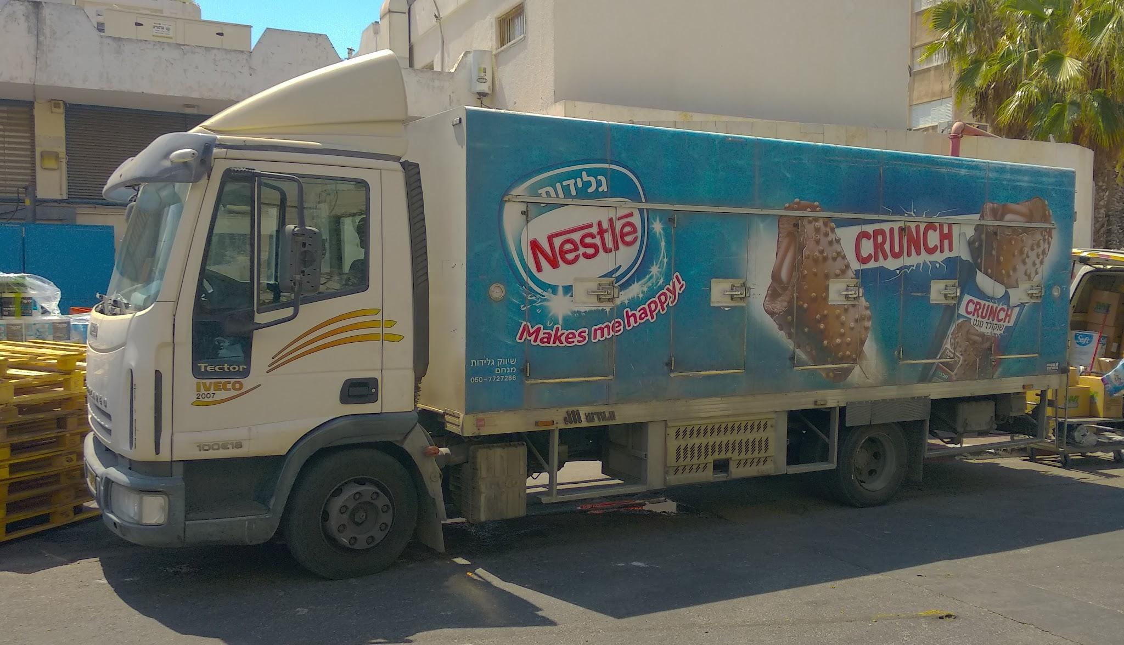

# **Nestle S.A**

## **INTRODUCTION:**

In today's rapidly changing world, businesses increasingly recognize the importance of sustainability as a fundamental pillar of their operations. Nestlé, a leading global food and beverage company, stands at the forefront of this movement, acknowledging the urgent need to address environmental challenges and embrace sustainable practices. With a rich history spanning decades, Nestlé has made significant strides in integrating sustainability into its core business strategy.

## **NESTLE’S SUSTAINABILITY STRATEGY:**

Nestlé, as a global food and beverage company, has formulated an overarching sustainability strategy that encompasses its commitment to people, the planet, and its products. This chapter delves into Nestlé's three pillars of sustainability and explores the initiatives and practices it has adopted to drive positive change.

**PEOPLE:**

Nestlé strongly emphasises improving the quality of life for individuals and communities. The company recognizes that its success is intertwined with the well-being of its employees and society. Nestlé promotes diversity, inclusion, and equal opportunities within its workforce, fostering a culture of respect and collaboration. Additionally, Nestlé extends its support beyond its employees by partnering with farmers, suppliers, and other stakeholders to ensure fair and responsible practices throughout the value chain.

**PLANET:**

Nestlé is committed to reducing its environmental impact and preserving natural resources. To achieve this, the company has implemented sustainable sourcing practices for its raw materials, working closely with farmers and suppliers to promote responsible agriculture and protect ecosystems. Nestlé also focuses on minimising waste generation, promoting recycling, and reducing greenhouse gas emissions. Through efficient water management and energy conservation, Nestlé aims to mitigate its ecological footprint and contribute to a more sustainable planet.

**PRODUCTS:**

Nestlé recognizes the importance of developing healthier and more sustainable product offerings. The company prioritises nutrition, portion control, and responsible marketing practices to promote healthier lifestyles and address public health concerns. Nestlé continually innovates to meet consumer demands for sustainable products, exploring ways to reduce sugar, salt, and artificial ingredients in its offerings. Moreover, Nestlé is dedicated to promoting sustainable packaging solutions and responsible disposal methods, aiming to minimise the environmental impact of its products throughout their life cycle.

## **KEY MILESTONES IN NESTLE’S SUSTAINABILITY JOURNEY:**

Nestlé's sustainability journey has been marked by significant achievements and milestones, demonstrating the company's unwavering commitment to driving positive change. This chapter explores key accomplishments in water usage reduction, sustainable agriculture, climate action, and packaging innovation.

1. **Reduction of water usage**
2. **Sustainable Agriculture**
3. **Climate Action**
4. **Packaging Innovation**

## **LOOKING TOWARDS PROSPEROUS FUTURE**

Moving forward, Nestlé continues to refine its impact measurement and reporting practices, leveraging advancements in data analytics and technology to enhance information accuracy, timeliness, and relevance.

CONCLUSION

* Amazon has become one of the most powerful and respected companies in the world. It has earned its enviable reputation by uncompromisingly focusing on customers, being willing to experiment, and learning from its mistakes when failing. Amazon’s logistics and shipping have reached the speed and professionalism that no other company can match. The retailer’s venture into advertising has brought success and disputed Google’s predominance as a digital-ad titan. Amazon’s foray into healthcare is expected to buoy the sector. Its constant employment of more workers contributes to positive US Non-Farm Payroll results. By investing in a private spaceflight company, Jeff Bezos has also proved that for him, quite literally, the sky's the limit.
* Seeing Amazon’s triumphant march forward, analysts cannot but agree that the company will soon dominate the world. Its wealth and the price of its stock are poised to grow. According to CNN Business, the AMZN stock price will be $174 in less than 12 months, about 24% above current levels. CNN Business also predicts that in 2026, the stock could hit $7,177.35. And as Amazon disrupts and masters new areas, it will become more and more difficult for other companies to oust it from its leading position.
* Nestle is the greatest food manufacturing company in the globe and it has experience and efficiency to understand the customers’ trends and respond quickly; furthermore, it has a wide distribution channel, a large number of human resources, and a strong financial position. The balance sheet and income statements for the last five years demonstrate that the net profit of Nestle Group had decreased every year except in 2014, but other financial indicators indicate that it was an extremely profitable food-manufacturing corporation. However, this company experienced many legal actions all over the world and experienced financial loss to obeying the Court orders, paying compensation, or destroying food packets; in this circumstance, the management of this company should develop ethical standards and enhance corporate value to provide quality products and reduce the number of claims**.**

# 

# 

# 

# **References used in the assignment:**

* <https://www.linkedin.com/pulse/from-vision-action-unraveling-nestl%C3%A9s-sustainability>
* <https://thecsrjournal.in/amazons-sustainability-report-global-corporate-social-responsibility-csr/>
* <https://www.learnstockmarket.in/share-price/nestle-india/>
* <https://companiesmarketcap.com/nestle/marketcap/>
* <https://www.investing.com/academy/statistics/amazon-facts/>
* <https://www.demandsage.com/amazon-statistics/>
* <https://stockanalysis.com/stocks/amzn/revenue/>
* <https://bstrategyhub.com/nestle-swot-analysis-2019-swot-analysis-of-nestle/>
* <https://bstrategyhub.com/swot-analysis-of-amazon-amazon-swot/>